**----------------------------------------------------------------**

**DL**

**END SEMESTER EXAM ANSWERS**

**Date: 2th May, 2023**

**----------------------------------------------------------------**

Q1.) Answer the following (Any Three)

A.) Consider an application of classifying the probability of a "Gift-Shop" to be Open or Closed. The dataset consists of the following attributes (into brackets its data types have been mentioned) i. Festive time (Binary) ii. Location of Shop (Categorical) iii. Popularity of shop (Numerical range between 1-10). Identify and explain which optimum activation function/s can be used to classify the same at the last layer of deep learning model?

Answer - Use **Softmax or Sigmoid function** for the classification problems

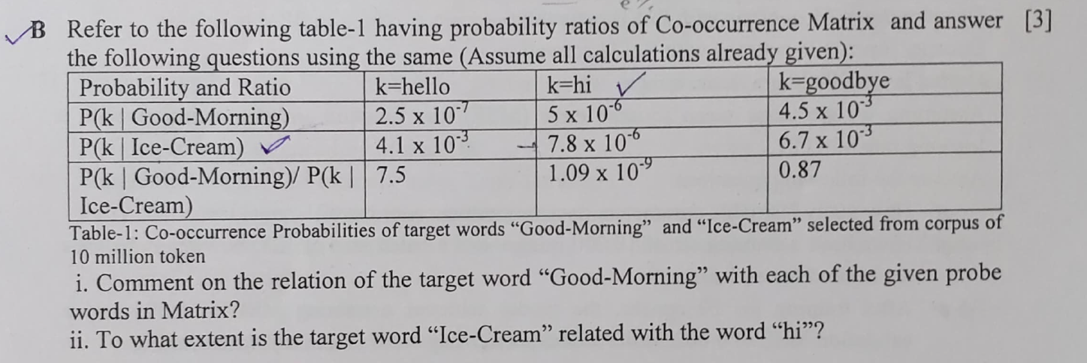

Answer –

Let i = “Good-Morning” and j = “ice-Cream”. The relationship of these words can be examined by studying the ratio of their co-occurrence probabilities with various probe words, k.

(i)

For words k related to **Good-Morning** but **not Ice-Cream**, say **k = hello**, we expect the ratio Pik/Pjk will be large.

For words k related to **Ice-Cream** but **not Good-Morning**, say **k = hi**, the ratio should be small.

For words k like **goodbye** that are either related to both Ice-cream and Good-Morning, or to neither the **ratio should be close to one**.

(ii) 7.8 * (10)^-6

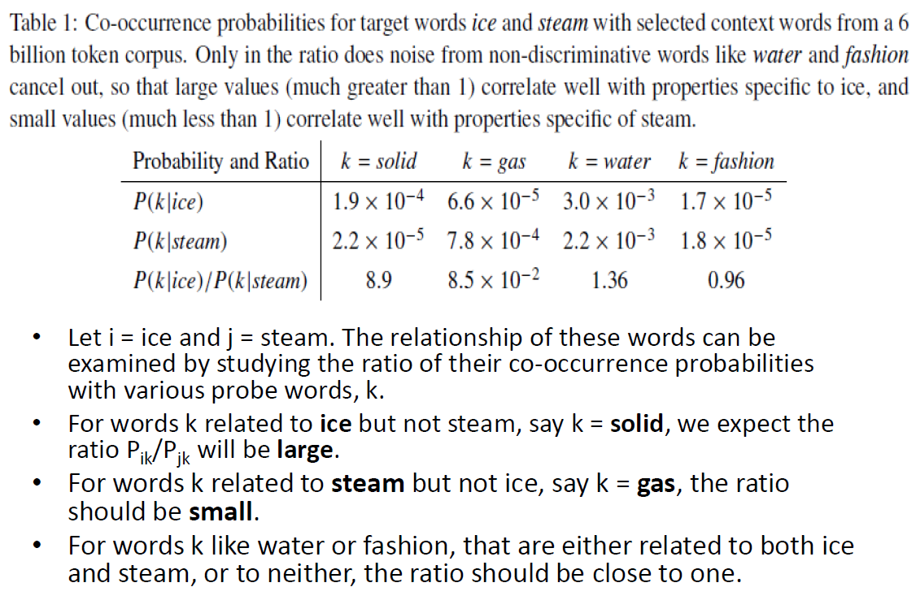

(3) Differentiate Operant learning and Classical learning in terms of natural learning. "An accountant has been rewarded for his performance, by which he has been motivated for working harder in his duties" is an example of which kind of learning? Justify your answer.

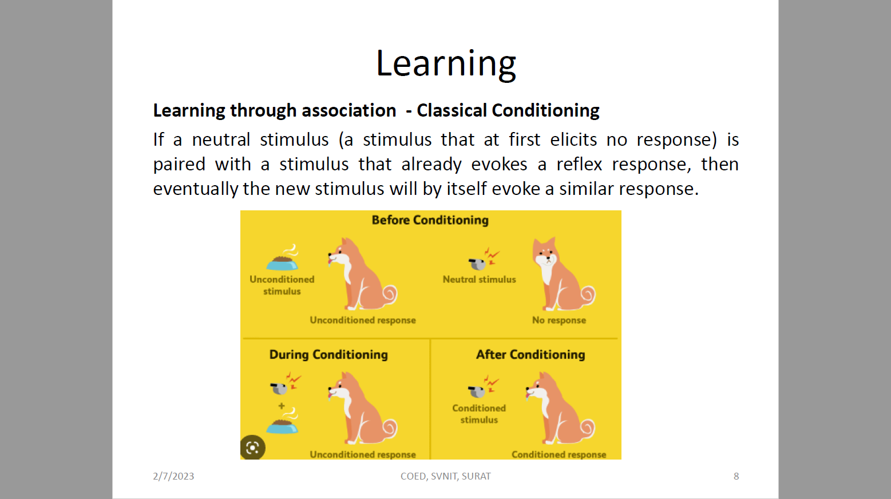

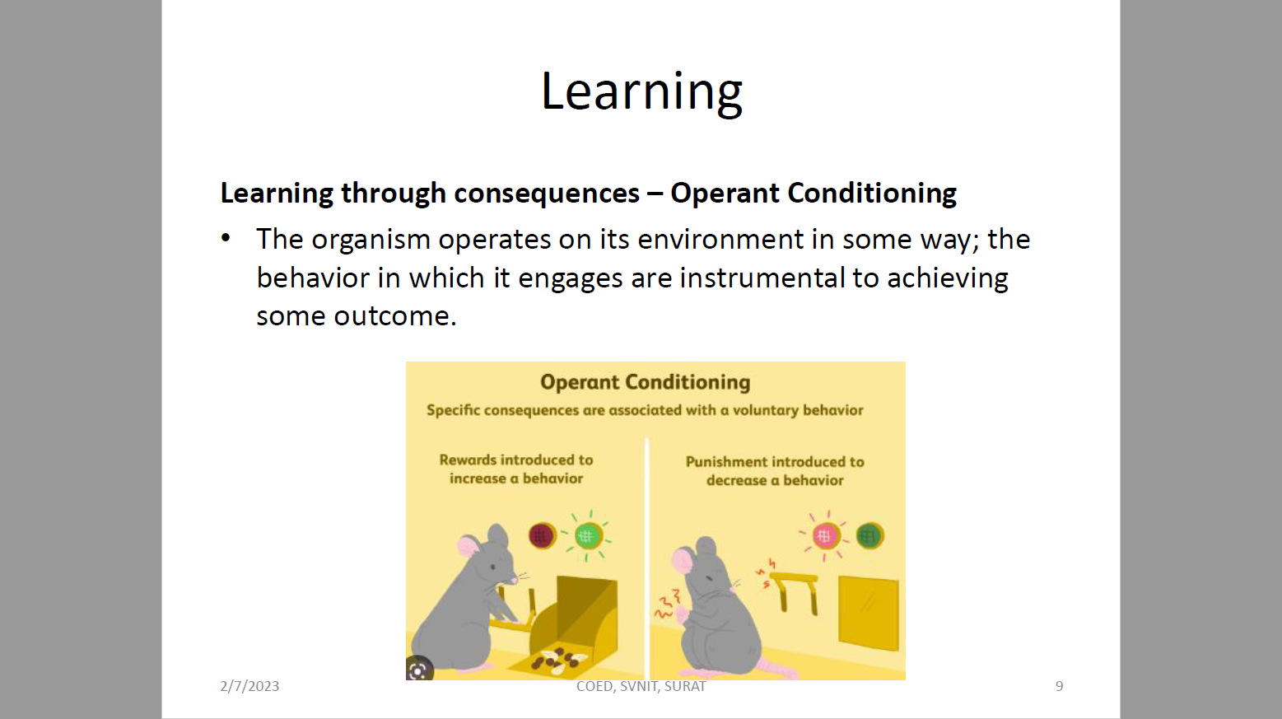

Answer – Operant Conditioning

(3) What do you mean by the Generalization Gap of a Deep Learning model? How can this problem be solved? Discuss any one technique in detail.

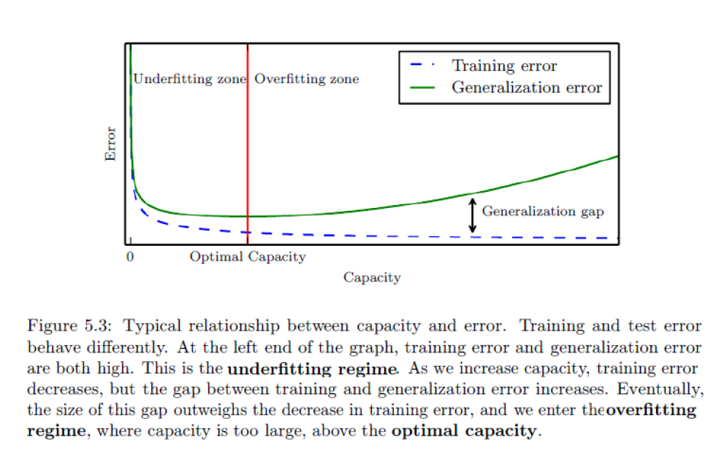

Soln – Regularization

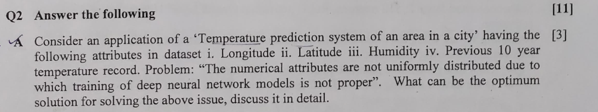

A – Normalization

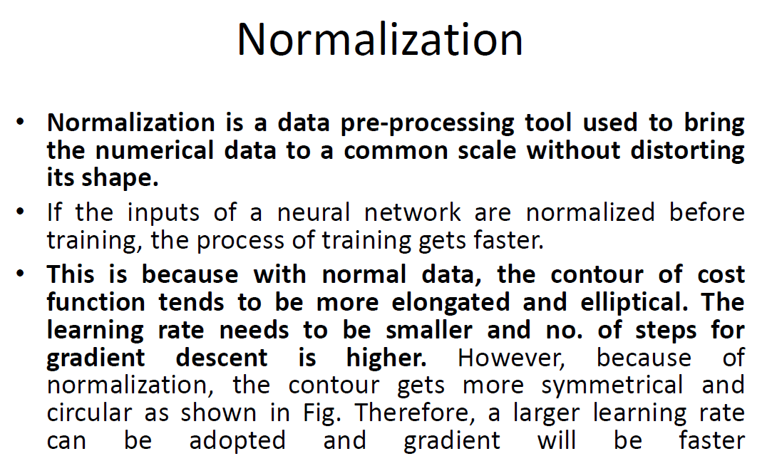

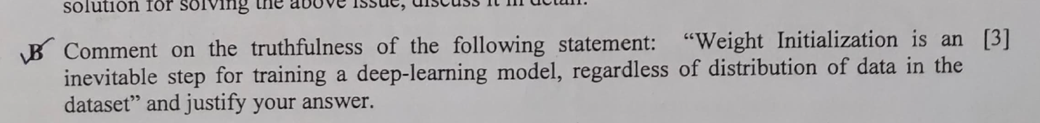

True, Zero, Too Small, Too Large, Uniform.

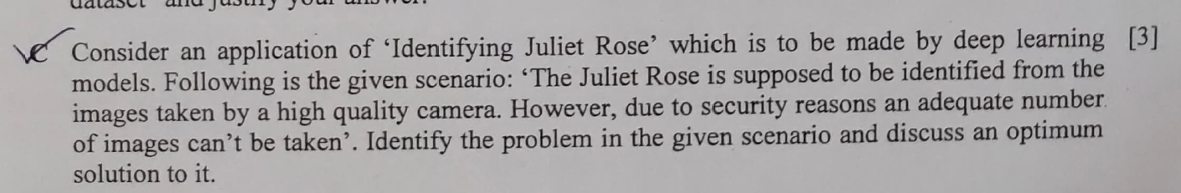

Data Augmentation

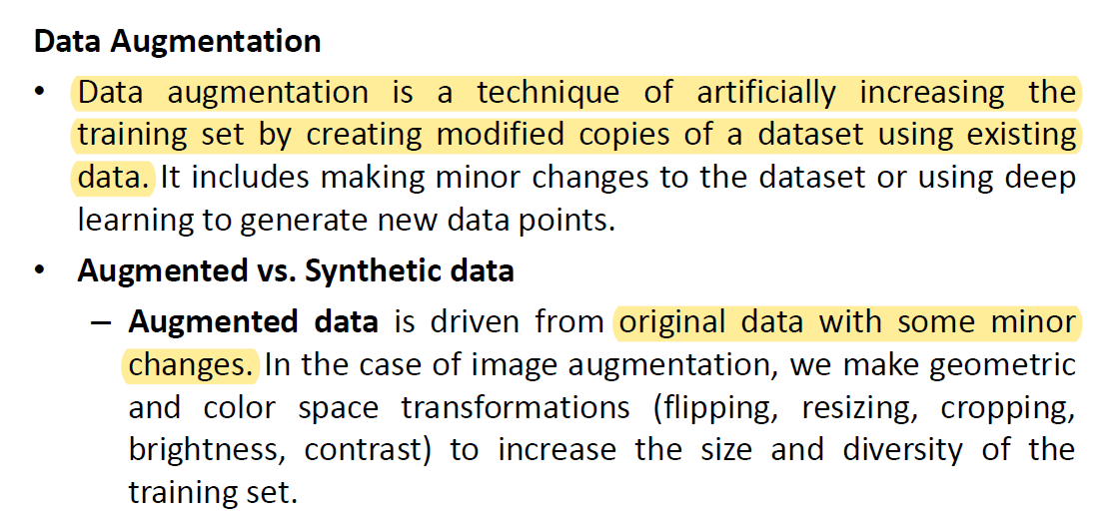

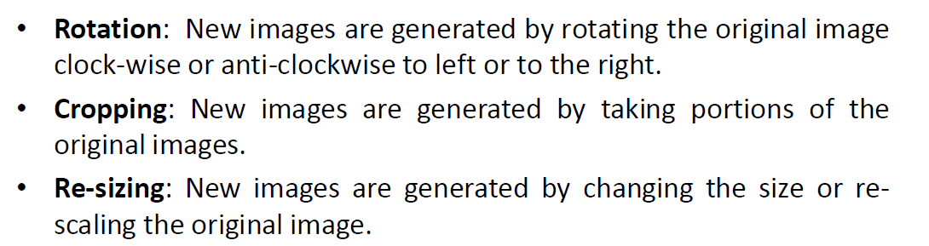

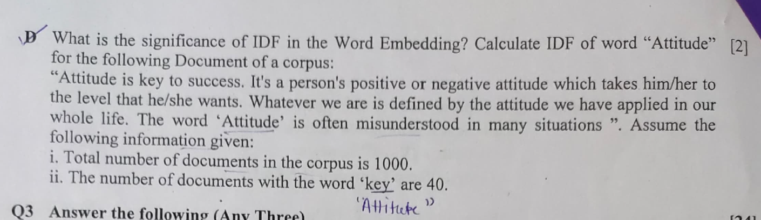

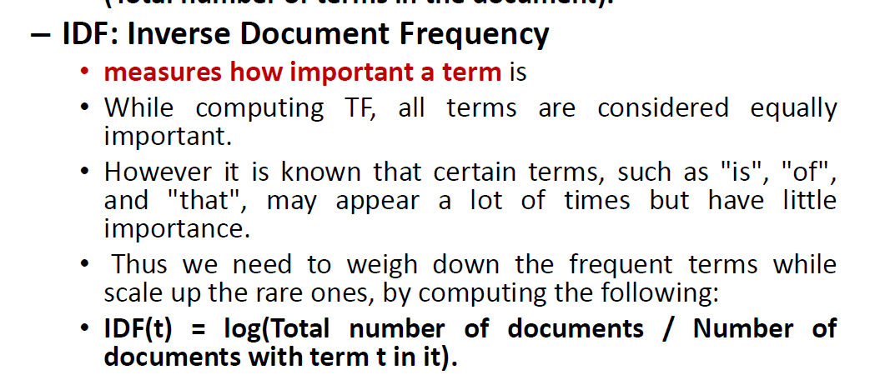

Ans – log (1000/40) = 3 – log(40) = 1.4

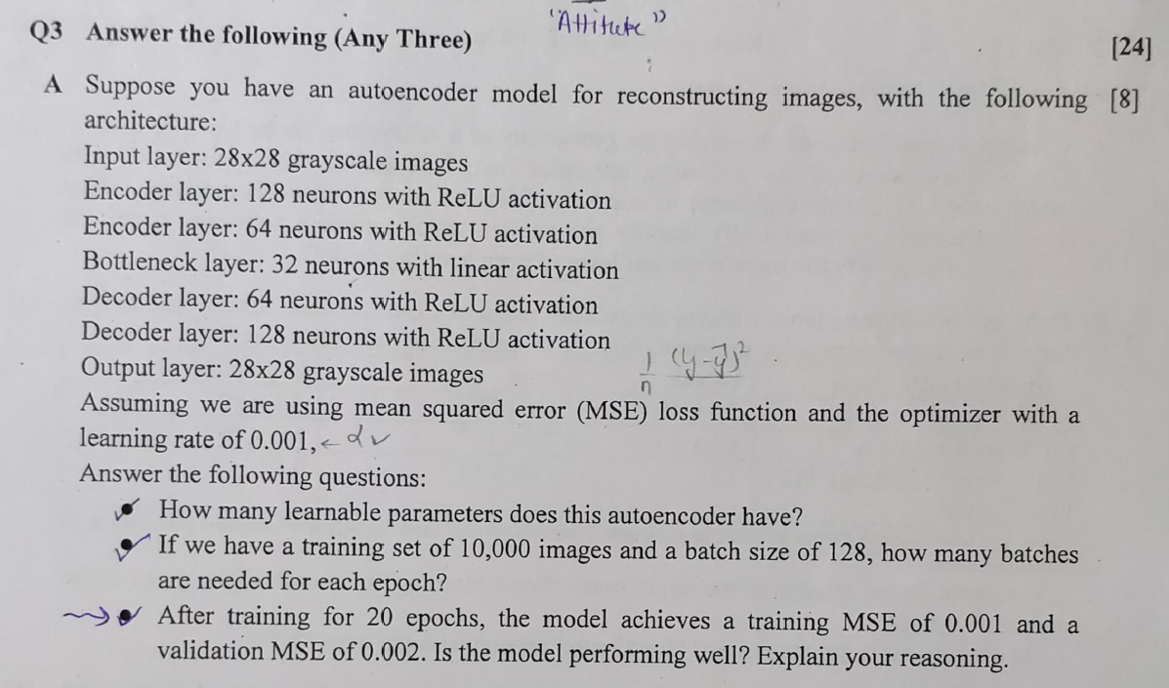

A.)

B.) 10k/128 = 79

C.)

